**Cell Nuclei Segmentation Application**

* **How to install:**

1. Download [Cell Nuclei Segmentation.zip] file.
2. Extract the comprised file in your local PC (needs ~ 1.8 GB).

* **How to used:**

1. 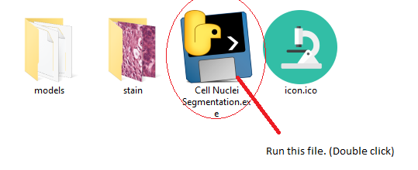After extracting the contents of the comprised zip file, double click on [Cell Nuclei Segmentation.exe] executable file.
2. 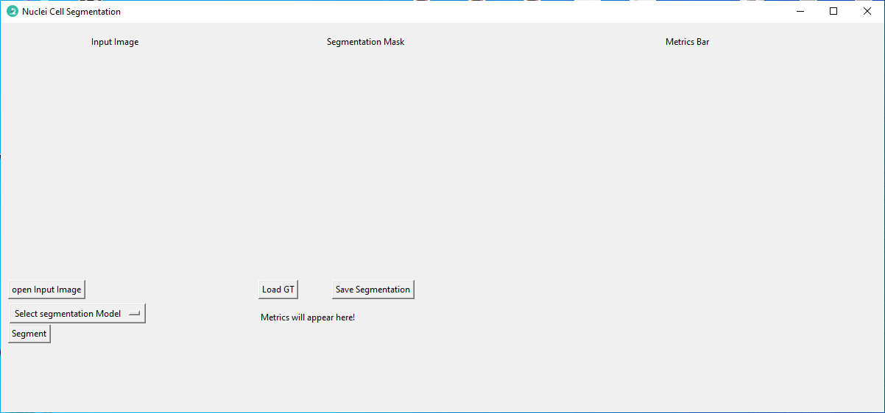Cell Nuclei Segmentation main window should start.
3. 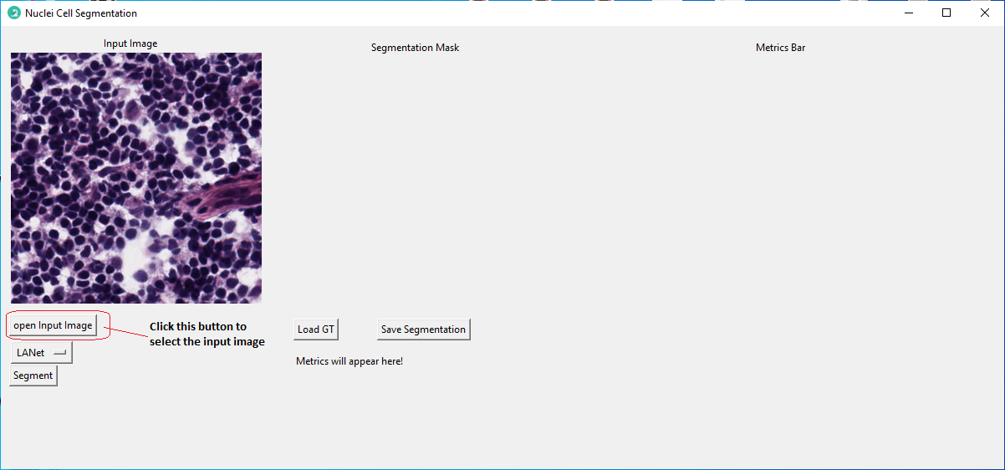Click [**Open Input Image**] button to select the WSI image.
4. 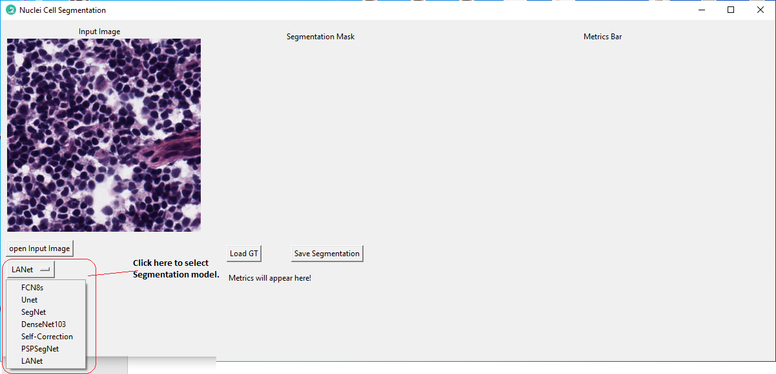Select the segmentation model.
5. 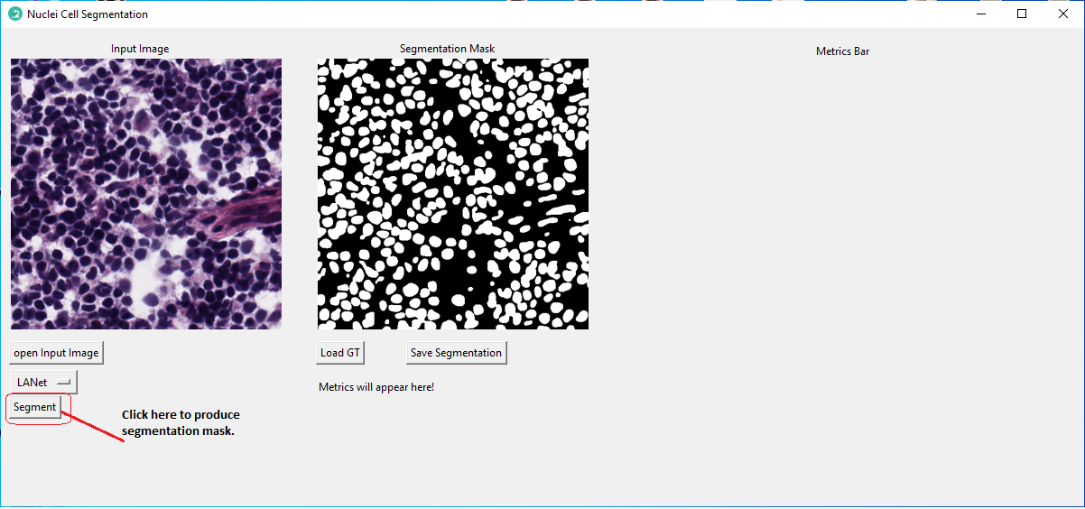Click on [**Segment**] button to produce segmented mask.
6. Click on [**Load GT**] button to evaluate the model segmentation mask with ground-truth if available.

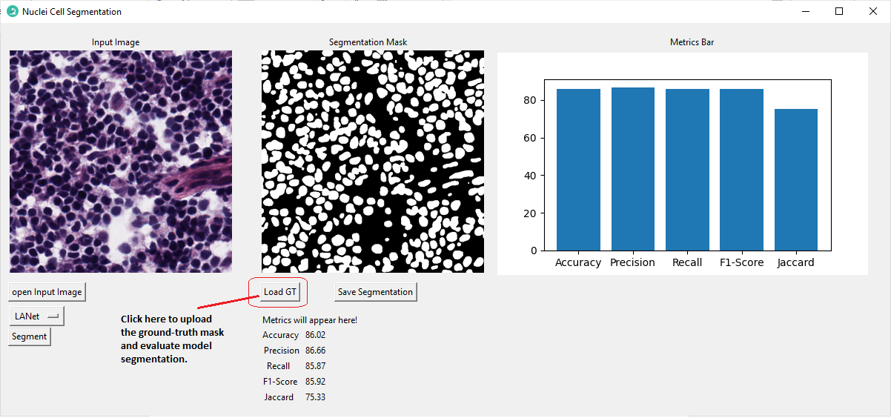

1. 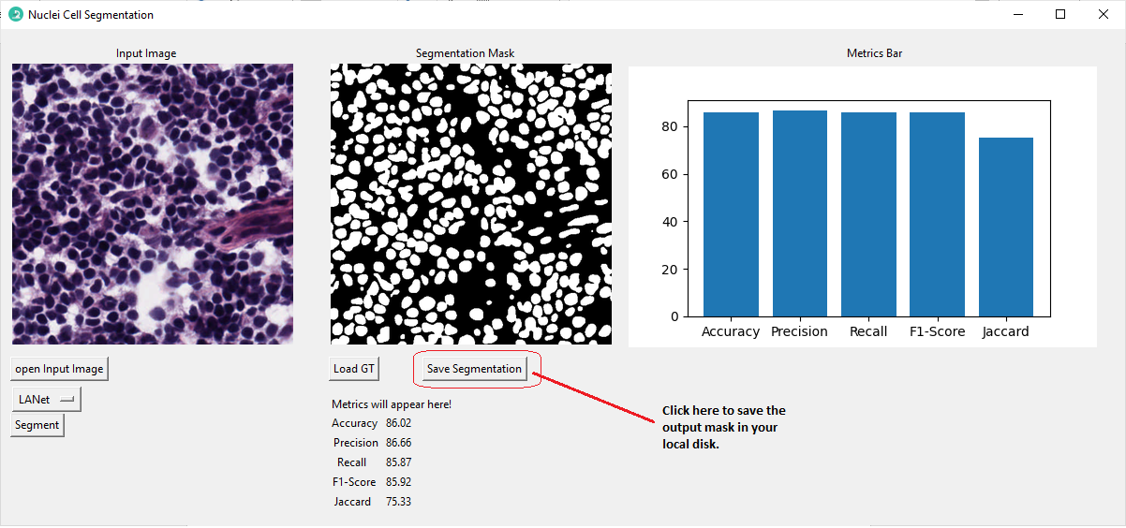Click [**Save Segmentation**] button to save the output mask into your local disk.